**Augmented Reality (AR) Demo’s**

AR demo’s use the camera to overlay X3D files into the scene. Inside the main AR file, the <Scene> node is appended with ‘ar=”true”’ so the <Scene> tag now appears as <Scene ar=”true”>.

**ar_ConePlusTexturedPlane.x3d**

Simple scene (variations will be used for upcoming demo’s) of a textured plane and orange Cone at (-1, -2, -5.5) and (1, 2, -6) respectively. Appears when clicking on a plane.

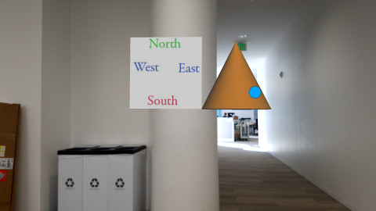

**ar_Text_Change-Font_Test.x3d**

Demonstrates that using various true-type-fonts (ttf) with various diffuse colors.

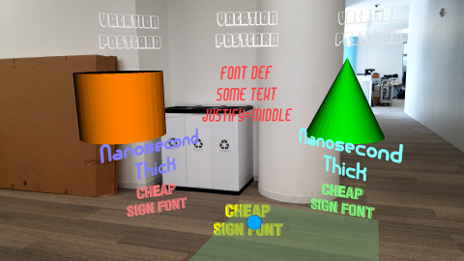

Clicking on the orange Cylinder changes the red text in the middle from “Font DEF Some Text Justify Middle” to “Samsung SRX”.

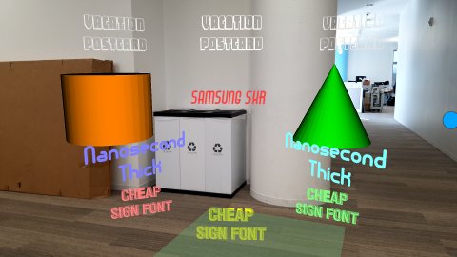

Clicking on the green Cone changes the same middle text to “Very Long New Text”.

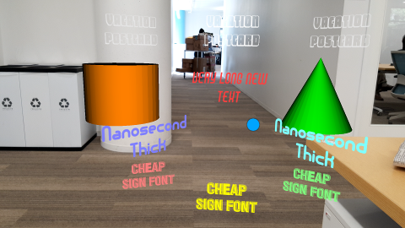

**ar_Inline_RGBBoxesAndCones01.x3d**

Begins with the Simple scene and includes an <Inline url="RGBBoxesAndCone.x3d"/>.

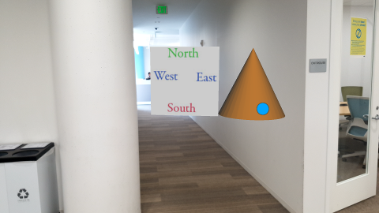

Clicking on a plane (such as the green plane pictured at the bottom) launches the Inline file that has an animated red Box at (-1.75, 1, -5), green Cone at (0, 0, -5) and blue Box at (1.75, 1, -5). Both boxes rotate around the y-axis and the green Cone rotates around the x-axis.

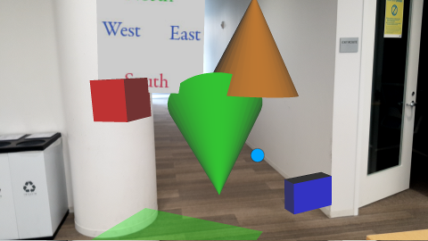

**ar_InlineInteractive.x3d**

Includes Simple scene plus a light blue Cone at (0, 0, -3).

There is also an <Inline url="ar_JavaScriptLightColors.x3d"/>

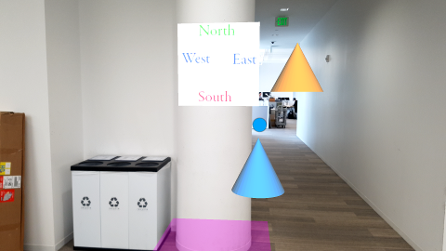

Clicking on a plane launches ar_JavaScriptLightColors.x3d with a rotating green Cone and white Sphere.

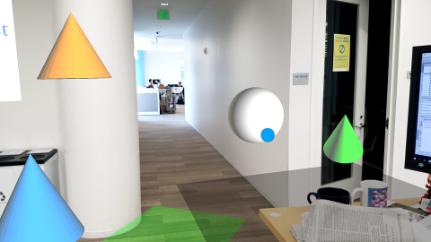

Clicking on the white Sphere changes it to purple and then to yellow, then clicking back to purple, etc.

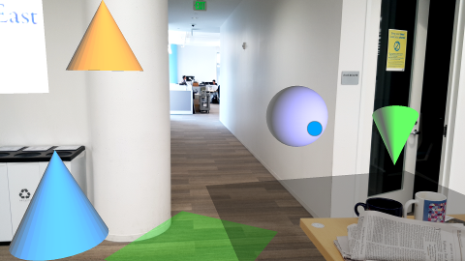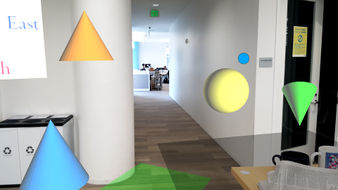

Finally, clicking on the plane on the floor adds another green Cone and white Sphere each time.

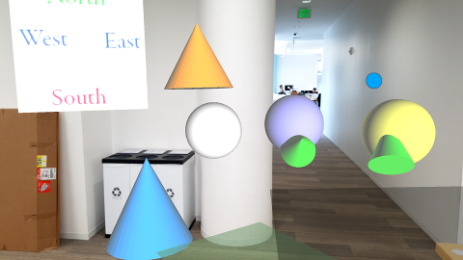

**ar_ProceduralAnim.x3d**

Clicking on the plane produces a greenish Cone and Sphere, both procedurally animated using JavaScript. The greenish Cone animates along a sine wave, while the Sphere moves left and right plus changes color.

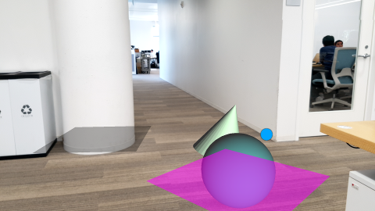

Further clicking on the plane launches the previously discussed ar_JavaScriptLightColors.x3d.

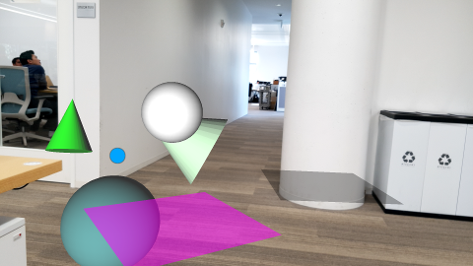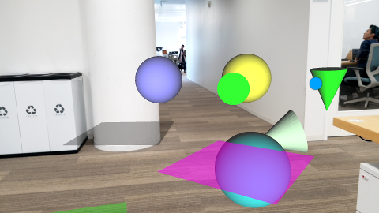

**ar_LaunchSphere.x3d**

Demo similar to the previous also has procedural animations, but controlled by clicks. The Sphere will roll away but returns upon clicking on the ‘RESET’ button. The Cylinder animates between white and red. Clicking “Change Color Animation” switches the color animation from green to blue.

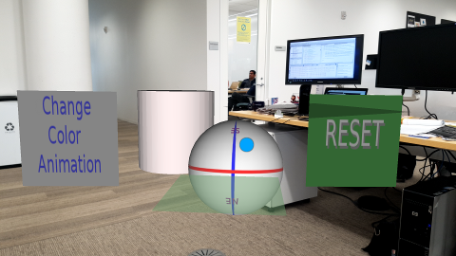

Sphere clicked on begins rolling away until beyond the far-clicppling plane.

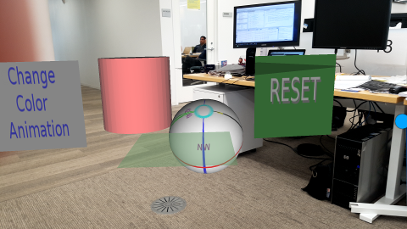

Clicking on ‘RESET’ highlights that button, and returns the Sphere. The “Change Color Animation” button also is highlighted and will change the color animation between green and blue. Click again, and the animation goes back to between white and red.

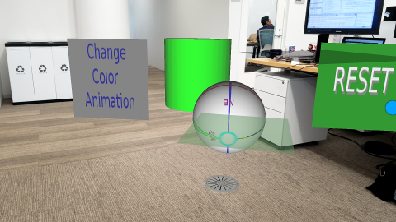

Clicking on addition planes on the floor launched the previously discussed ar_JavaScriptLightColors.x3d.

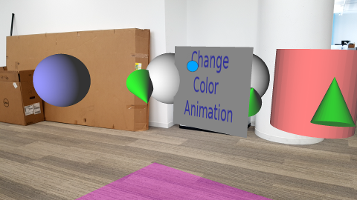

**ar_Menu_InlineWithBool.x3d**

Demo launched when clicking a plane brings up three menu items. The green Cone is a marker at (0, 0, -5) plus an orange Cone at (-5, 0, 0) and blue Cone at (5, 0, 0).

There are three Inline files, the first has set ‘load=”true”’ for skull.x3d while the next two Inline files have ‘load=”false”’.

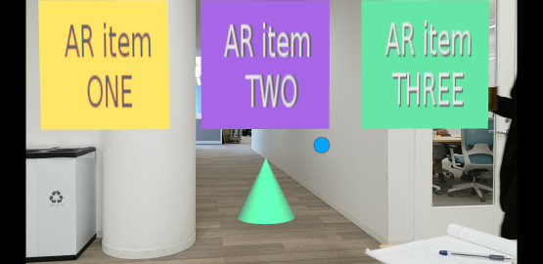

Clicking on another plane, launches skull.x3d.

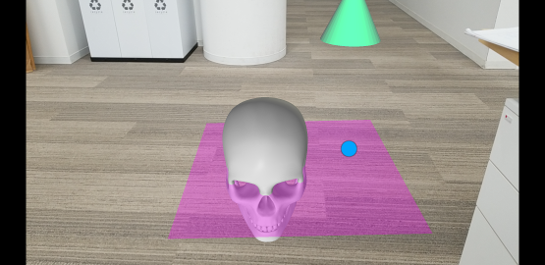

Clicking on the middle menu changes the second’s Inline’s ‘load=”true”’ and the others set ‘load=”false”’. Then clicking on another plane launches ar_JavaScriptLightColors.x3d

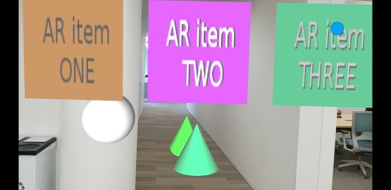

Finally, clicking on menu item 3, sets the ‘load=”true”’ for gear.x3d inside the Inline node, and the other two Inline files to ‘load=”true”’. The gear, which appears more as a top, is dark brown and in the center bottom of the screen capture.

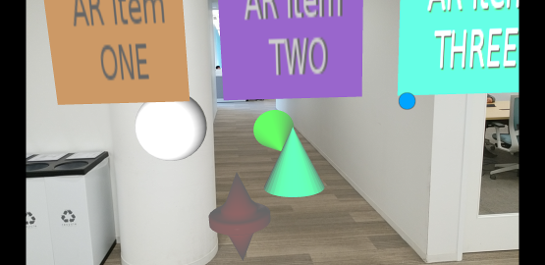

**ar_Menu_InlineWithMFString.x3d**

Similar to the previous demo, except instead of changing the load boolean property of three different Inline nodes, only a single <Inline> node and the ‘url’ string property is changed based on the menu item selected to the desired x3d file.

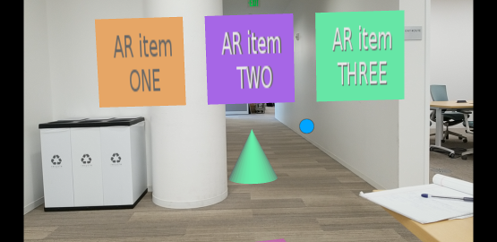

The left menu sets the lone <Inline> node’s url to the skull.x3d file.

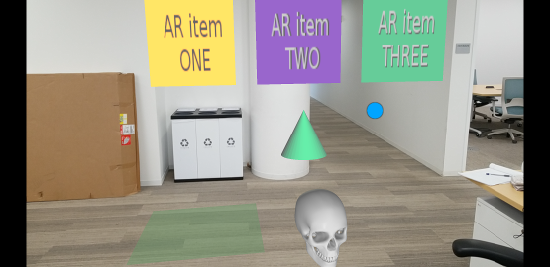

Selecting the middle menu set the lone <Inline> node’s url to the ar_animation01.x3d file which has two textured planes of a dog, and ‘north-east-west-south’ plane, which is also animated.

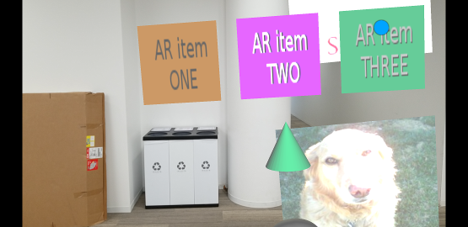

The right-most menu changes to <Inline> url to ar_JavaScriptLightColors.x3d.

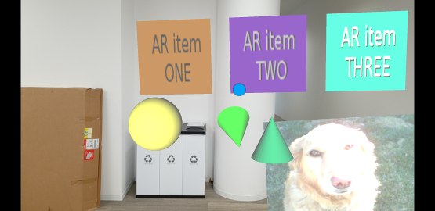

**ar_MovieTexture_PitchSpeed.x3d**

Demo will launch a movie when clicking on a plane. In addition, there are several menu items to stop, start, pause, plus speed up, slow down or reset the speed of the movie.

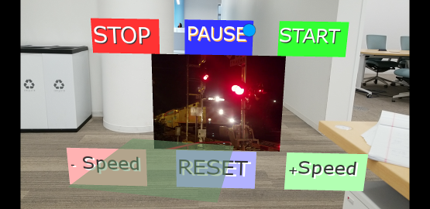

**ar_Menu3_Inline_Movie-Anim-Skull.x3d**

Similar demo to previous with three menu items. If no menu item is selected than ar_JavaScriptLightColors.x3d with the rotation green Cone plus interactive color Sphere.

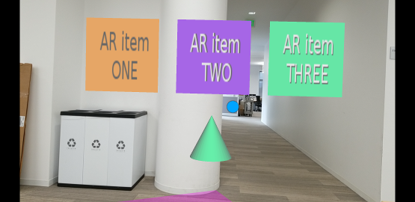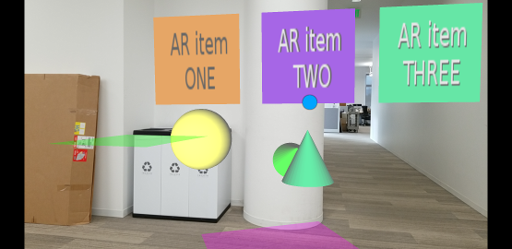

Selecting the far left menu item launches the movie demo.

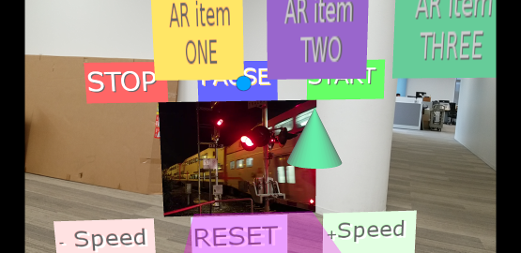

Menu two, after clicking a plane on the floot, displayes the two textured flat meshes of the dog plus the animated North-East-West-South texture map.

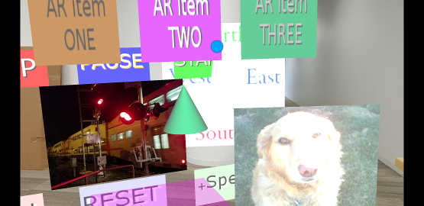

Selecting the right-most item 3, then clicking a plane, launches the skull. Demo was relaunched.

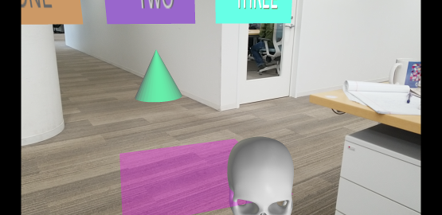

**ar_NavInfo_visLimit_01.x3d and ar_NavInfo_visLimit_02.x3d**

Two similar demos with six Cones beginning at -5 units and each subsequent Cone another 5 units back.

The first demo uses the <NavigationInfo/>’s default ‘visibilityLimit’ which leaves the far clipping plane at 10 units in AR mode. Only the closest green Cone appears, the rest are beyond the far clipping plane.

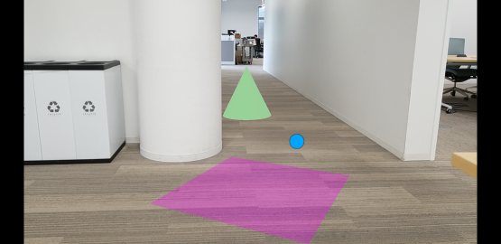

In the second X3D file, the ‘visibilityLimit’ is set to 20, and shows the three closest Cones.

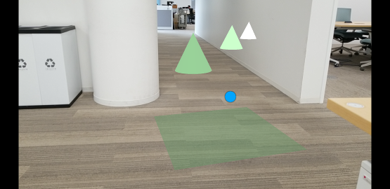

**ar_Inline_glTF.x3d**

This demo has the <inline> node url set to ‘Box.gltf’, meaning the X3D file loads a glTF file

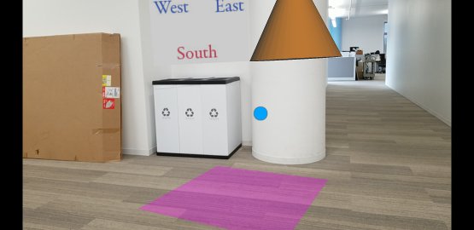

The glTF file is a red Box.

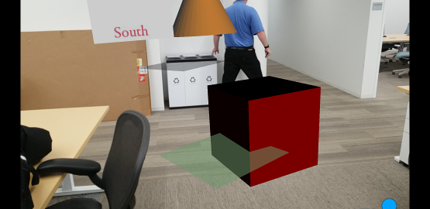

And continuing to click on a plane brings up additional red glTF boxes.

